1, install netui client on the report server
For example, I installed here “C:\Program Files\QAD\ShinEtsu QADEE 2010.1 2010 EE\container\QAD.Client.exe”

2, create report batch parameter file
Attached is my sample, which I used to test in Shanghai QAD’s ShinEtsu environment.
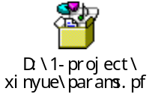
Explanation for following two parameters in the file:
-workspace:ShinEtsu.ShinCH(Domain.Site)
-report-batch:apitest(I created a batchid named “apitest” with 36.14.1 “Batch ID Maintenance”)
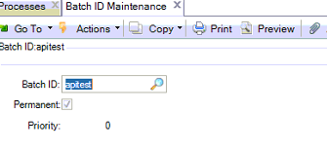
3, create bat file
Attached is my sample, which will be added to schedule task list on your report server. Of course, you can click it to run to see result when test. (After run it, report batch will be processed.)
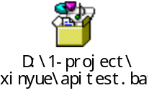
4, To test your setup, you can create a report batch by yourself.
Create a new schedule, and you need to set “batch id”, “printer”, “Run only once”. As to others, just let it go. (Later our API program will create report batch like that)
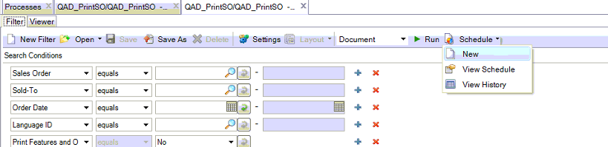
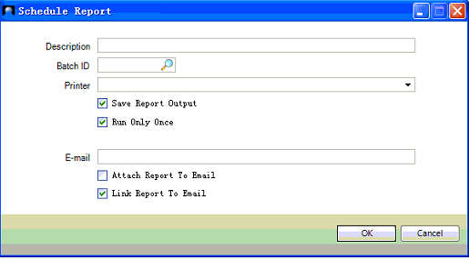

5, you can inquiry batch result through the following 3 functions.
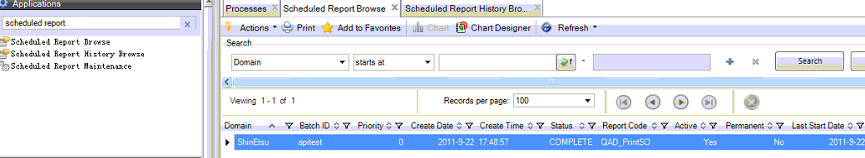

6, Generalized Codes setup (36.2.13)

Field Name: ZZ_REPORT_API1
Value: userIdentifier
Comment: userPassword

Field Name: ZZ_REPORT_API2
Value: batchID
Comment: entity

(The following printer setup logic is now used in api program. I’m informed that the logic will be changed later….)
Field Name: ZZ_REPORT_API3
Value: function code
Comment: printer

Function code list:
fun code | trigger | table | API program | Print Report
olw_pir | zzolw.t | Zzovdlot_mstr | zzpirapi.p | Process Issue Report
olw_pmpors | zzolw.t | Zzovdlot_mstr | zzpmporsapi.p | Perform Manufacturing Process Origin Record Sheet
oslw_pir | zzoslw.t | Zzovdsublot_mstr | zzpirapi.p | Process Issue Report
slw_dds | zzslw.t | Zzsellot_mstr | zzddsapi.p | Diversion Direction Sheet
slw_ovdtl | zzslw.t | Zzsellot_mstr | zzovdtlapi.p | OVD Target List
slw_pps | zzslw.t | Zzsellot_mstr | zzppsapi.p | Perform Processing Sheet

For example:
Field Name: ZZ_REPORT_API3
Value: olw_pir
Comment: \\\\cont23\\copr62
(Note the double slashes)

